Contents

Part A 2

1. 2

2. 2

Advanced 1. 4

Advanced 2. 6

Part B 7

1. 7

Part C 9

1. 9

2. 10

3. 11

4. 12

# Part A

## 1.

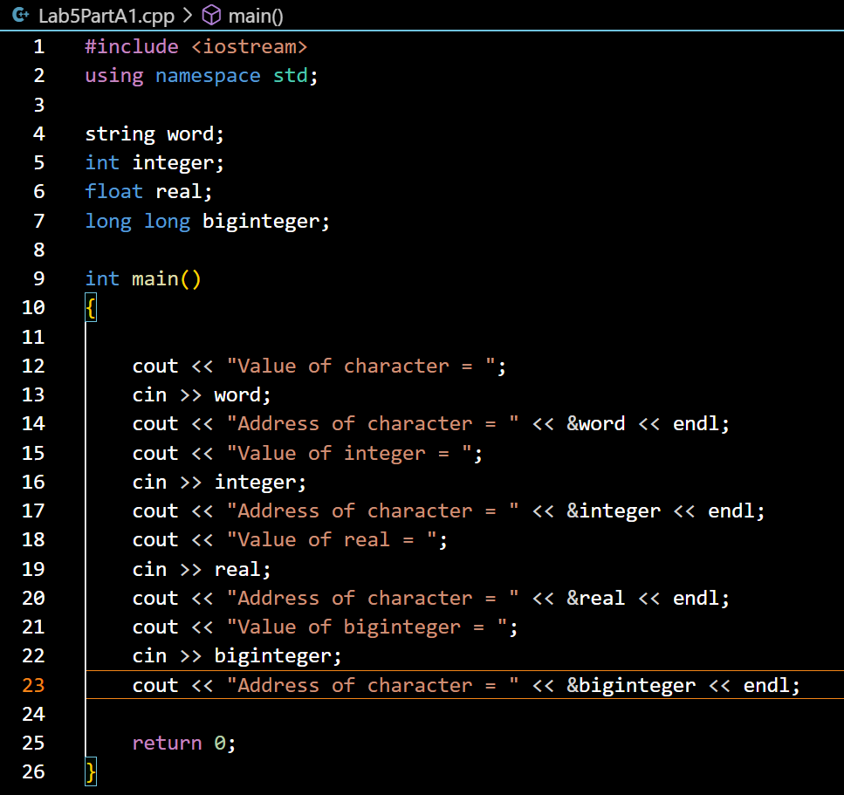

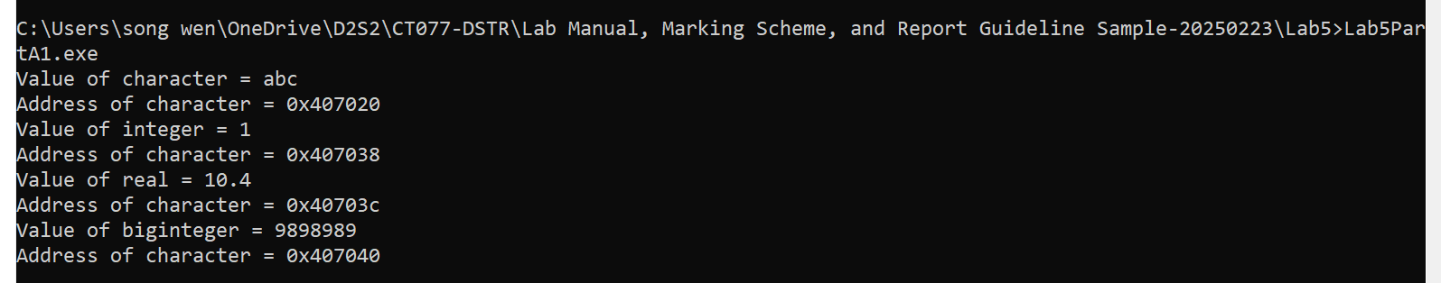

## 2.

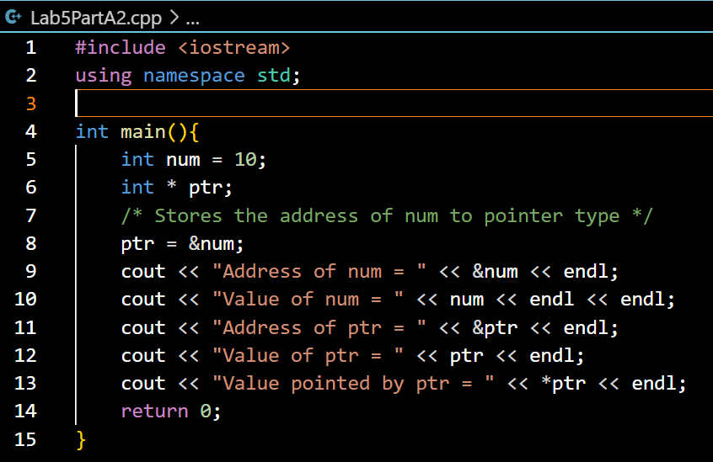

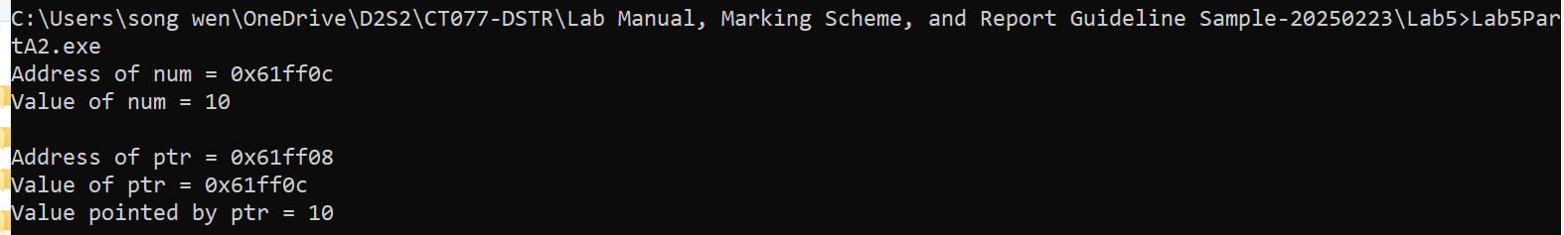

## Advanced 1.

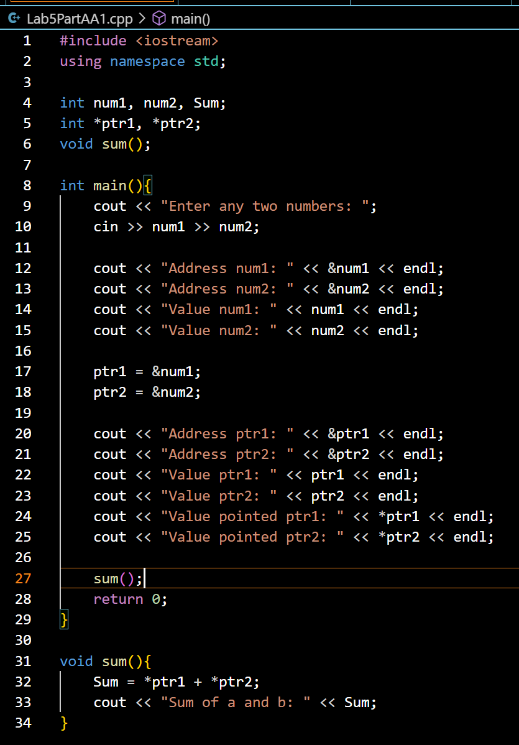

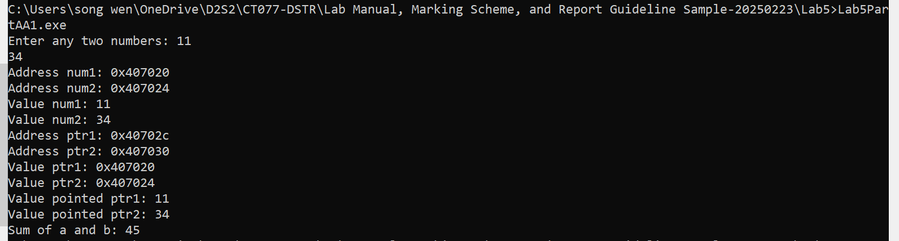

## Advanced 2.

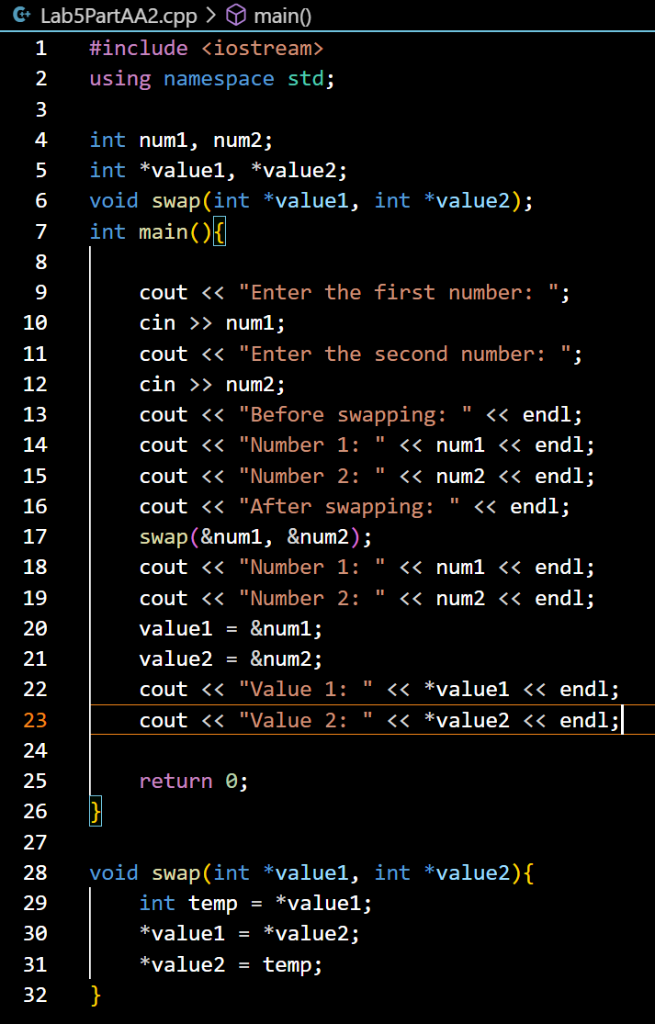

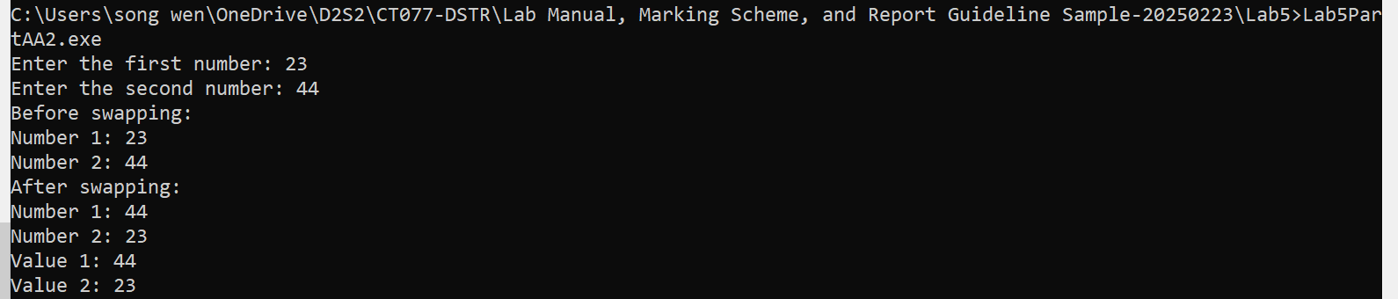

# Part B

## 1.

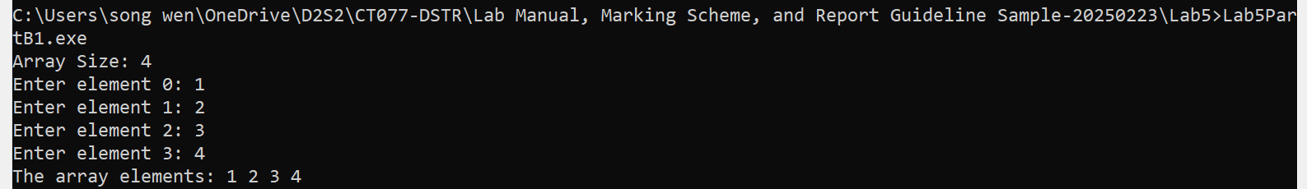

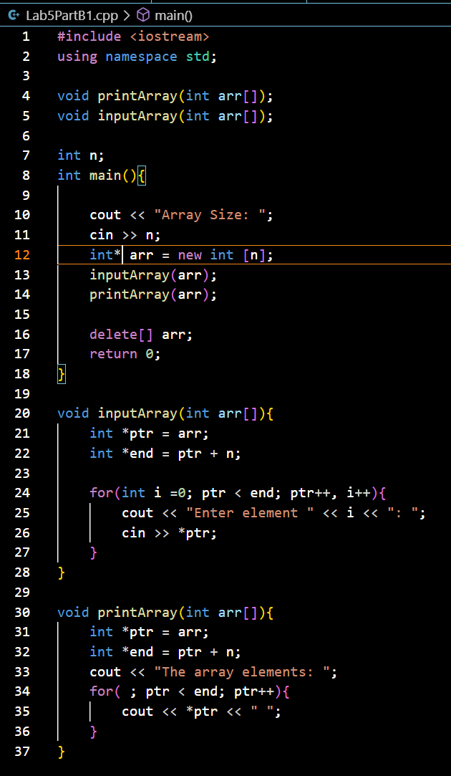

# Part C

## 1.

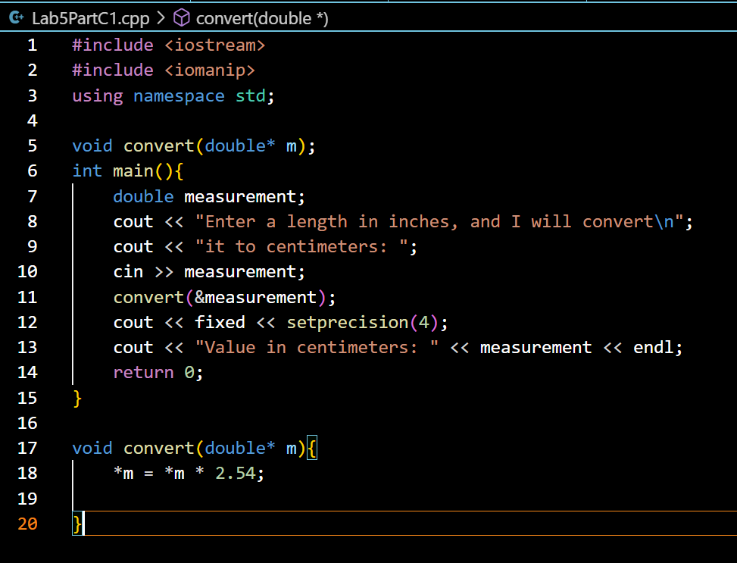

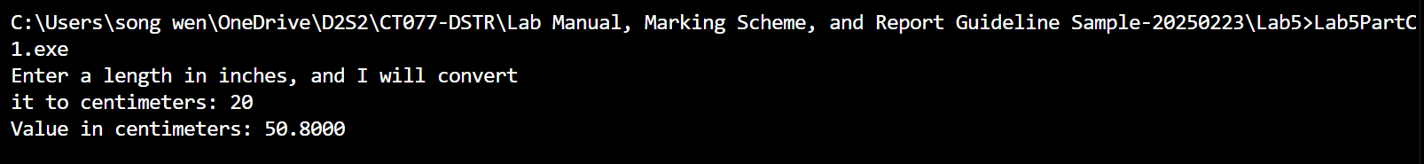

## 2.

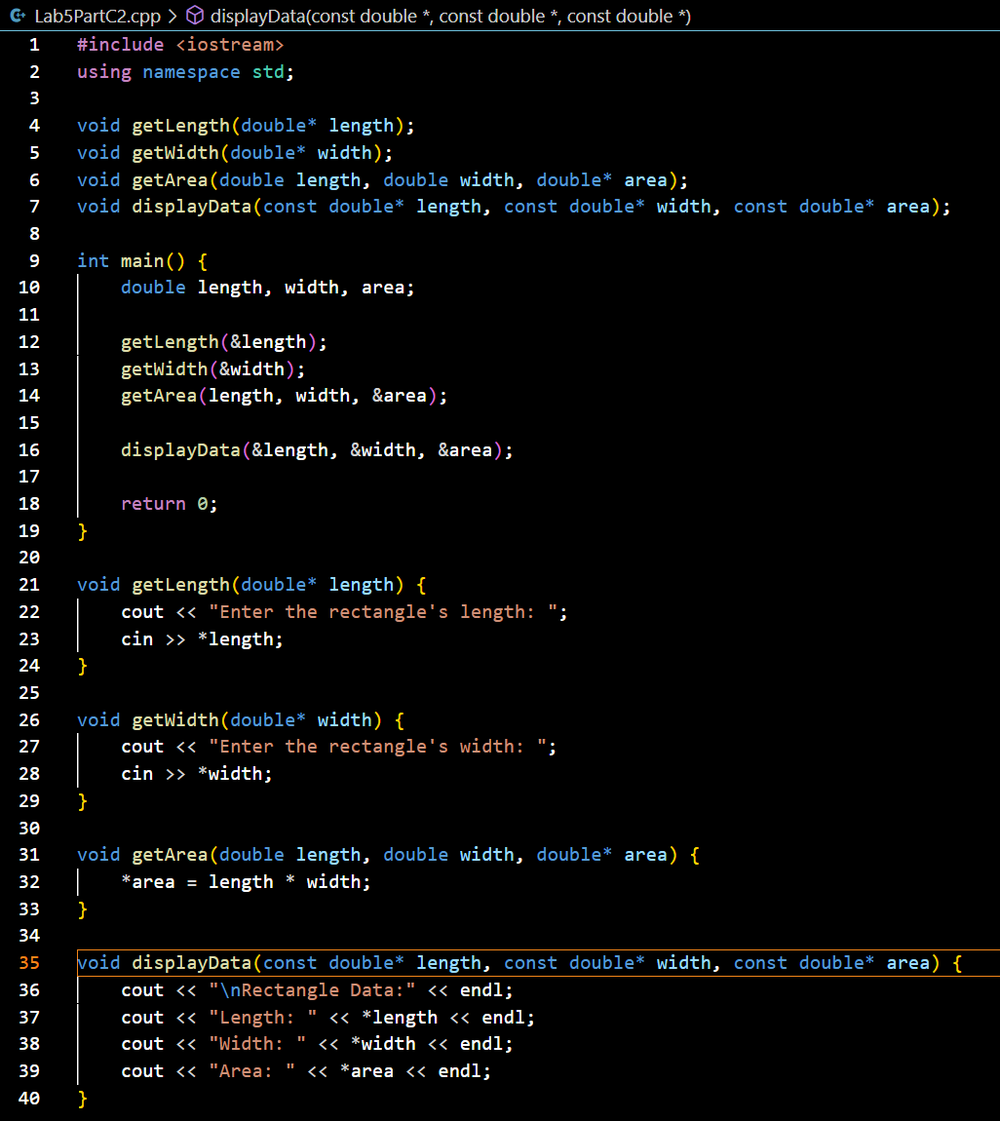

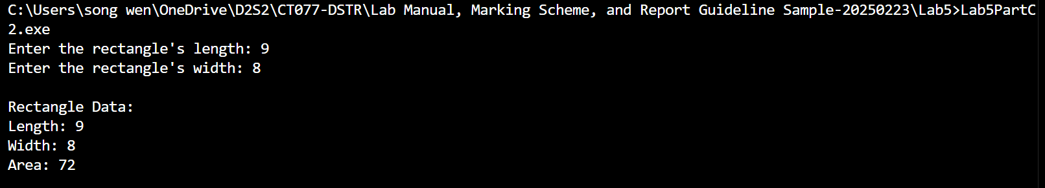

## 3.

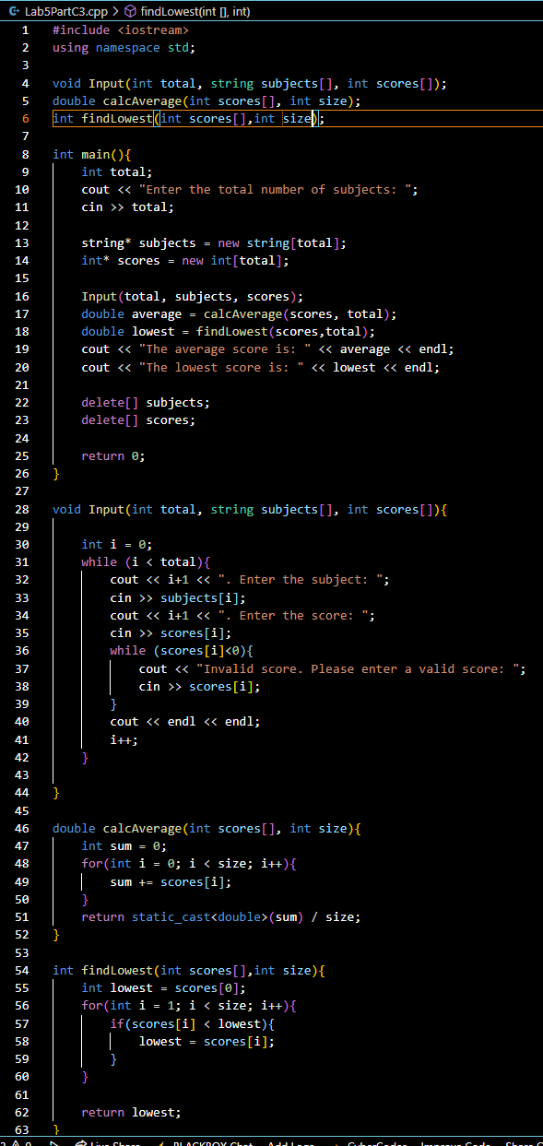

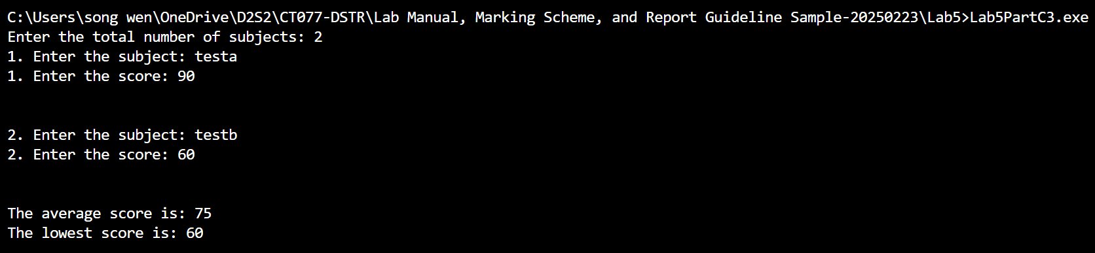

## 4.

